Check Azure soft/hard limits and available IPs in Azure Subnet

Login to ATA production

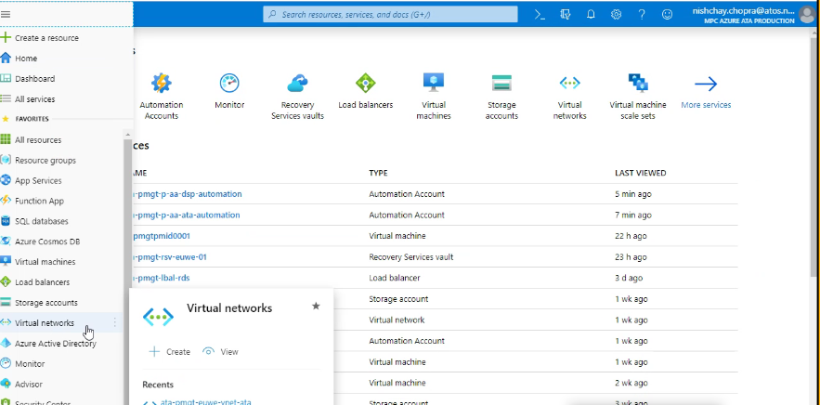

Click on ATA Vnet

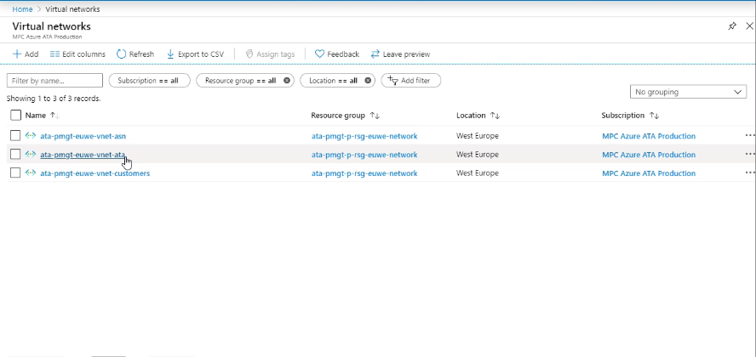

Check the address space

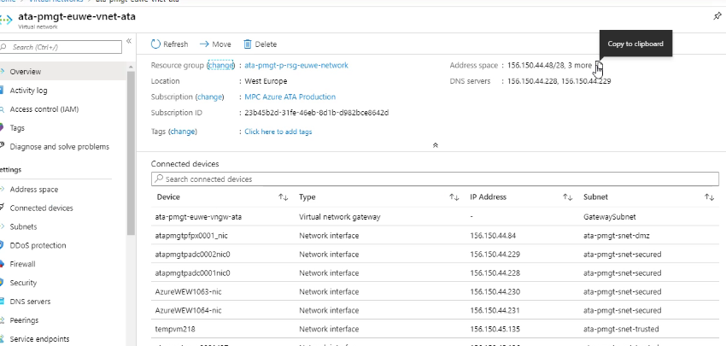

Check the available address if this reduces to 4-5 and clear an alert

